1. To list all records with sal > 2000 and comm>200.



1. To list all record with job=’Clerk’ or sal>2000.

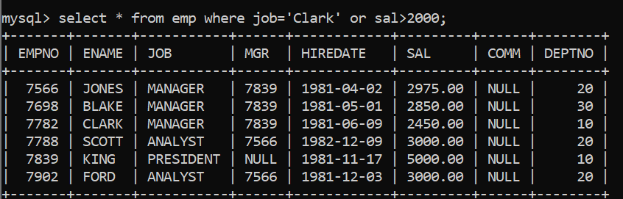

1. To list all the record with sal=1250 or 1100 or 2850

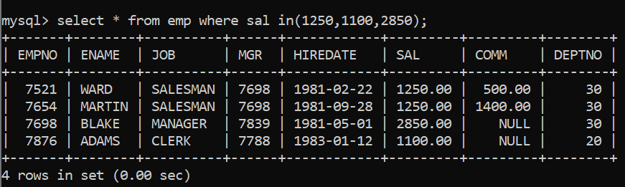

4. To list all employees with sal>1250 and <2850;

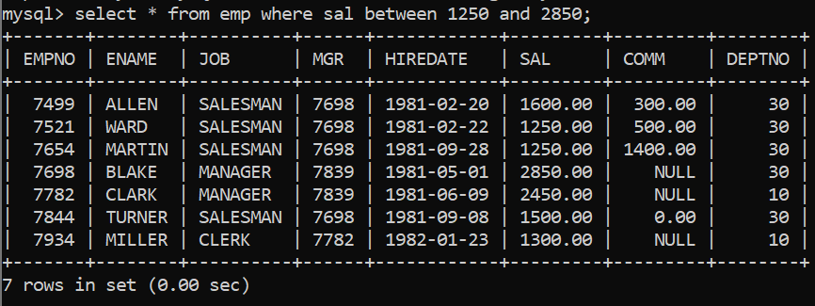

1. To list all employees with name ends with AS.



1. To list all employees with job starts with C and ends with K .

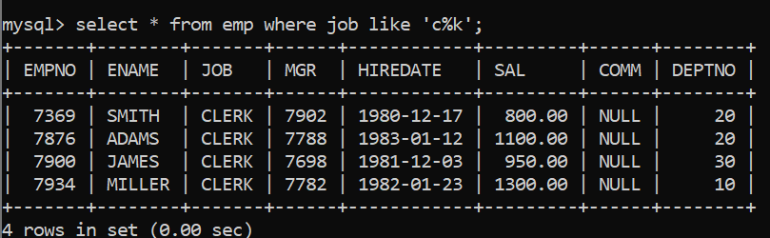

1. To list all employees with job contains L at third position and M at third last position.

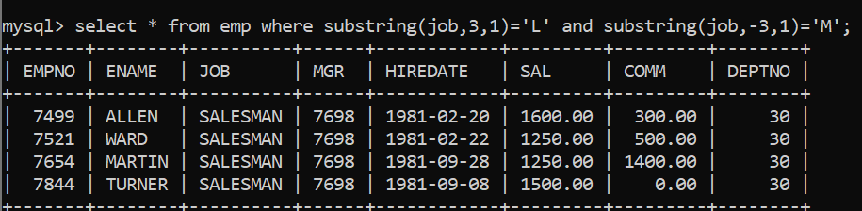

1. To list all the record with sal not equal to 1250 or 1100 or 2850.

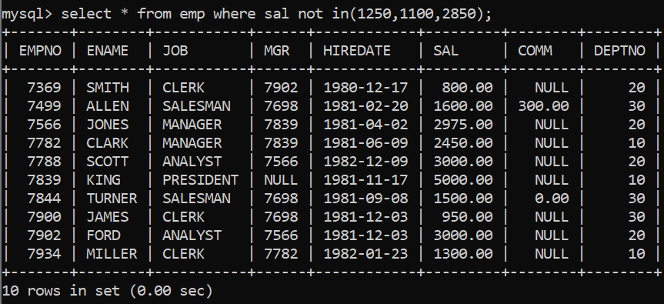

1. To list all employees with salnot >1250 and <2850.

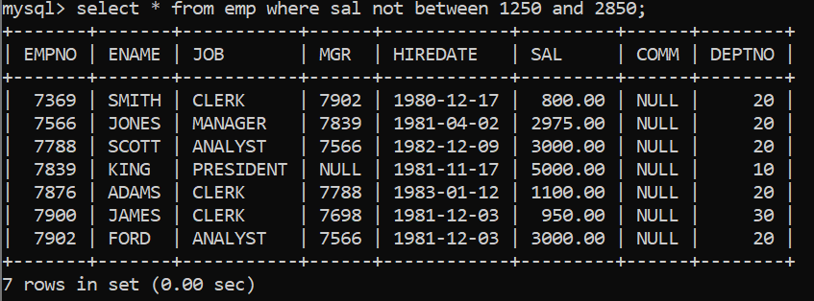

1. To list all employees with job starts with C , E at 3rd position and ends with K.

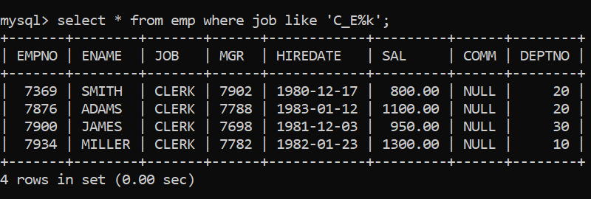

1. To list all rows with comm is null.

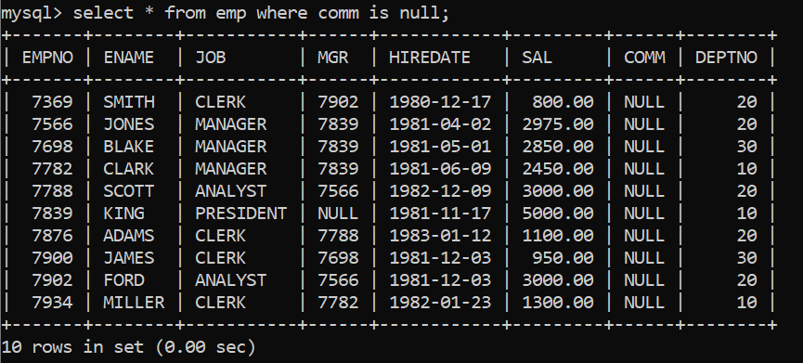

1. To list all employees with sal is null and name starts with ‘S’.



1. To list all employees with job contains 5 characters.

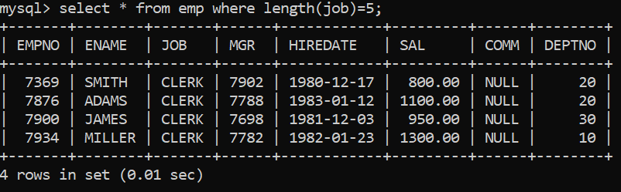

1. To list all employees with name contain ‘A’ at 1 position and job Contains 5 characters.

